System Requirements Statement (SRS) –

Gamers Valley

Doc. Ref. :

Version : 0.4

Status : Drafted

Created by : Kenji Tanaka

Date : 04-Dec-2012

1. Introduction 3

2. Functional Requirements 4

2.1 CUSTOMER Module 5

2.2 DISTRIBUTOR Module 11

2.3 ADMIN Module 17

2.4 P**rofessional PC Builder(Experts)** Module 21

2.5 Use Case Diagram.............................................................................................................................22

THIS DOCUMENT CONTAINS 23 NUMBERED PAGES

# Introduction

This document explains the system requirements and scope for developing e-PC Build System.

e-PC Build System could divide the four main parts, Customer part, Distributor part, Admin part and the Expert part.

# Functional Requirements

The Account part of e-PC build System has three modules which are divided 13 processes described as below.

|  |  |  |  |
| --- | --- | --- | --- |
| **No** | **BRS requirement ID** | | **Description** |
| **2.1** | **Customer Module** | | |
| **2.1.1** | **F1** | | **Account Creation Process** |
| **2.1.2** | **F2** | | **Login Process** |
| **2.1.3** | **F3** | | **Forgot Password Process** |
| **2.1.4** | **F4** | | **Change Password Process** |
| **2.1.5** | **F5** | | **Update Profile Process** |
| **2.1.6** | **F6** | | **Search Devices and Buy** |
| **2.1.7** | **F7** | | **View Customer’s Feedback** |
| **2.1.8** | **F8** | | **Give Feedback** |
| **2.2** |  | **Subscribed Customer Module** | |
| **2.2.1** | **F9** | | **Registration Process** |
| **2.2.2** | **F10** | | **Login Process** |
| **2.2.3** | **F11** | | **Change Password Process** |
| **2.2.4** | **F12** | | **Update Profile Process** |
| **2.2.5** | **F13** | | **Upload Requirements** |
| **2.3** | **Distributor Module** | | |
| **2.3.1** | **F14** | | **Registration Process** |
| **2.3.2** | **F15** | | **Login Process** |
| **2.3.3** | **F16** | | **Forgot Password Process** |
| **2.3.4** | **F17** | | **Change Password Process** |
| **2.3.5** | **F18** | | **Update Profile Process** |
| **2.3.6** | **F19** | | **Upload Product Information** |
| **2.3.7** | **F20** | | **Upload Offers and Schemes** |
| **2.3.8** | **F21** | | **Provide Service for Sold Products** |
| **2.4 Admin Module** | | | |
| **2.4.1** | **F22** | | **Login Process** |
| **2.4.2** | **F23** | | **Forgot Password Process** |
| **2.4.3** | **F24** | | **Change Password Process** |
| **2.4.4** | **F25** | | **Update Profile Process** |
| **2.4.5** | **F26** | | **Sales Report Generation** |
| **2.4.6** | **F27** | | **Authenticating Registration Requests** |
| **2.4.7** | **F28** | | **View Feedback** |
| **2.5 Experts Module** | | | |
| **2.5.1** | **F29** | | **Registration Process** |
| **2.5.2** | **F30** | | **Login Process** |
| **2.5.3** | **F31** | | **Forgot Password Process** |
| **2.5.4** | **F32** | | **Change Password Process** |
| **2.5.5** | **F33** | | **Update Profile Process** |
| **2.5.6** | **F34** | | **Upload Information of Pre-built PC’s** |
| **2.5.7** | **F35** | | **View Requirements** |

## Customer Module

* Customer is the user of system who wants to buy the product.

* He is also able to view the market prices of products.

### Account Creation Process

* Gamer’s Valley System compels to create the account when the customer proceeds to buy the product. So, Gamer’s Valley System should provide the function which makes customer creates new account.
* When customer creates new account, he will be able to buy product and proceed for further steps.
* The Account creation process information

The Account creation process information consists of some items described as below.

1. UserID
2. Password
3. First Name
4. Last Name
5. E-mail address
6. User Type
   * All items are compulsory demanded.
   * UserID

* The UserID should be unique. If the UserID correspond with not case-sensitive to other which is previously registered, the UserID should not be registered as an account.
  + Password
* The Password has constrains which makes the Password consists of more than or equal 8 and less than or equal 16 characteristics including characters described as below.

1. Numeric figure (at least one)
2. Capital alphabet (A-Z)(at least one)
3. Small alphabet (a-z)(at least one)
4. Special character (#, $, %, &, etc.) (at least one)

* The Password is masked by dummy characters. The re-entering Password is demanded.
* The Password must be encrypted in e-Farming System.
  + User Type

The User Type falls into two categories described as below.

1. Regular Customer
2. Subscribed Customer

* The User Type defines also two types of users: "Regular Customer ", "Subscribed Customer".
* In an Account Creation Process, the user can select type of customer.
* Contact Details
* The Contact Detail consists of some items described as below.

1. Permanent Address
2. Contact Phone No
   * All items are compulsory demanded.
   * Permanent Address

* Permanent Address should be filled.
* But only the state should be selected from options.
* The Security Question information

The Security Question information is needed when customer lost their Password. This information consists of two items described as below.

1. Selected Question
2. Answer
   * All items are compulsory demanded.
   * Some questions which are difficult to answer for anyone else are prepared in advance.

E.g. which color do you like most?

* + A question should be selected from options by the Customer, and the Answer is registered by the Customer.
* Login information should be entered on one screen, and then Customer information and Security Question information should be entered on another screen.

### Login Process

* Gamer’s Valley System always compels user authentication before using itself except when a new account is successfully created.
* The user authentication demands UserID and Password. The UserID and the Password should be checked in three ways.
  + First, The UserID and the Password should be existed and correct.
* If The UserID and the Password are not equal to what the user has registered, the user authentication cannot be provided.
  + Finally, UserID should be available.
* The Administrator can decide whether the UserID is available or suspended – Refer to the SRS of the Admin part.
* If Customer is rejected, user authentication is not provided for system user.
* The Customer account should alive till he log-out from the system.
* Only when the three checks are successfully completed, Customer can be placed on respected page.

### Forgot Password Process

* When system user lost their Password, the recovery method should be provided by Gamer’s Valley system.

The recovery method is described as below.

* + First, system user enters their UserID for Gamer’s Valley System.
  + Next, Gamer’s Valley System demands the Answer which has been registered since when the Account was created.
  + Only when the Answer is correct, Customer get the new password by E-mail which also has been registered since when the Account was created.
  + The new password is automatically generated by Gamer’s Valley System.
* Of course, the new password should consist of more than or equal 8 and less than or equal 16 characteristics including at least a numeric figure, a capital alphabet, a small alphabet, and a special character.
* As a consequence, The Customer could get the Customer authentication using the new password.
  + Then, the Customer had better change the new password manually.
* If the Answer is not correct, otherwise, the correct Answer is demanded for user again.
  + In that case, Of course, Customer couldn’t get the new password.

### Change Password Process

* When Customer wants to change their Password, the measure should be provided by Gamer’s Valley System.
* Therefore, Gamer’s Valley System should provide the function which is available after getting the Customer authentication.
* The function demands the current password and the new password.
  + Of course, the new password should consist of more than or equal 8 and less than or equal 16 characteristics including at least a numeric figure, a capital alphabet, a small alphabet, and a special character.
  + The current password and the new password are masked by using dummy characters.
  + The new password is demanded to enter twice to avoid a typing error.
* Only when the current password is correct, Customer could change their Password.
* When the current password is changed into new password, Gamer’s Valley System compels user authentication again.

### Update Profile Process

* Gamer’s Valley System should provide the function which makes the account updated for Customer.
* The information Customer could update is described below.

1. Login information
2. User information
3. Security Question Information

* The Login information

The updatable items as described below.

1. First Name
2. Last Name
3. E-mail address
   * All items are compulsory demanded, but updating is optional.

* The User information

The updatable items as described below.

1. User Name
2. User Phone No
3. E-mail address
4. Permanent address
   * All items are compulsory demanded, but updating is optional.

* The Security Question information

The updatable items as described below.

1. Selected Question
2. Answer
   * All items are compulsory demanded, but updating is optional.

### Search Devices and Buy

* Customer can search various products according to their interest and buy it.
* He can also surf through various types of products while window shopping.

### View Customer’s Feedback

* By this function customer can view feedback of other customers who have purchased the same product .

### Give Feedback

* This function will provide section to customer to give feedback for the products he purchased.
* This feedback will be in two ways,
  + - * 1. By giving rating stars out of total 5 stars.
        2. By writing Comments.

## Subscribed Customer Module

### Registration Process

* Gamer’s Valley System compels to create the account before using it. So, Gamer’s Valley System should provide the function which makes farmer creates new account.
* When Customer creates new account, the function demands four information described as below.

1. Login information

2.Contact Details

3.Security Question Information

4.Payment information.

* The Login information

The Login information consists of some items described as below.

5.UserID

6.Password

7.First Name

8.Last Name

9.E-mail address

10.User Type

* + All items are compulsory demanded.
  + UserID
* The UserID should be unique. If the UserID correspond with not case-sensitive to other which is previously registered, the UserID should not be registered as an account.
  + Password
* The Password has constrains which makes the Password consists of more than or equal 8 and less than or equal 16 characteristics including characters described as below.

1.Numeric figure (at least one)

2.Capital alphabet (A-Z)(at least one)

3.Small alphabet (a-z)(at least one)

4.Special character (#, $, %, &, etc.) (at least one)

* The Password is masked by dummy characters. The re-entering Password is demanded.
* The Password must be encrypted in Gamer’s Valley System.
  + User Type

The User Type falls into three categories described as below.

1.Customer

2.Subscribed Customer

* The User Type defines also two types of user; " Customer ", " Subscribed Customer ".
* In an Account Creation Process, the user can select Wholesaler.
* No one could select The Administrator, because Administrator is implemented to Gamer’s Valley System in advance.
* Contact Details
* The Contact Detail consists of some items described as below.

1.Permanent Address

2.Contact Phone No

* + All items are compulsory demanded.
  + Permanent Address
* Permanent Address should be filled.
* But only the state should be selected from options.
* The Security Question information

The Security Question information is needed when Subscribed Customer lost their Password. This information consists of two items described as below.

1. Selected Question
2. Answer
   * All items are compulsory demanded.
   * Some questions which are difficult to answer for anyone else are prepared in advance.

E.g. which color do you like most?

* + A question should be selected from options by the Subscribed Customer, and the Answer is registered by the Subscribed Customer.

### Login Process

* Gamer’s Valley System always compels user authentication before using itself except when a new account is successfully created.
* The user authentication demands UserID and Password. The UserID and the Password should be checked in three ways.
  + First, The UserID and the Password should be existed and correct.
* If The UserID and the Password are not equal to what the user has registered, the user authentication cannot be provided.
  + Finally, UserID should be available.
* The Administrator can decide whether the UserID is available or suspended – Refer to the SRS of the Admin part.
* If Customer is rejected, user authentication is not provided for system user.
* The Customer account should alive till he log-out from the system.
* Only when the three checks are successfully completed, Customer can be placed on respected page.

### Forgot Password Process

* When system user lost their Password, the recovery method should be provided by Gamer’s Valley system.

The recovery method is described as below.

* + First, system user enters their UserID for Gamer’s Valley System.
  + Next, Gamer’s Valley System demands the Answer which has been registered since when the Account was created.
  + Only when the Answer is correct, Customer get the new password by E-mail which also has been registered since when the Account was created.
  + The new password is automatically generated by Gamer’s Valley System.
* Of course, the new password should consist of more than or equal 8 and less than or equal 16 characteristics including at least a numeric figure, a capital alphabet, a small alphabet, and a special character.
* As a consequence, The Customer could get the Customer authentication using the new password.
  + Then, the Customer had better change the new password manually.
* If the Answer is not correct, otherwise, the correct Answer is demanded for user again.

### Update Profile Process

* Gamer’s Valley System should provide the function which makes the account updated for Customer.
* The information Customer could update is described below.

1. Login information
2. User information
3. Security Question Information

* The Login information

The updatable items as described below.

1. First Name
2. Last Name
3. E-mail address
   * All items are compulsory demanded, but updating is optional.

* The User information

The updatable items as described below.

1. User Name
2. User Phone No
3. E-mail address
4. Permanent address
   * All items are compulsory demanded, but updating is optional.

* The Security Question information

The updatable items as described below.

1. Selected Question
2. Answer
   * All items are compulsory demanded, but updating is optional.

### Upload Requirements Process

* Subscribed customer can send the requirement of his setup to the experts through this function .
* Subscribed customer can also see the pre-built PC by experts and according to his requirement he can buy any pre-built PC’s.

## DistributorModule

**•** Distributorshould be responsible for following activities**,**

### Registration Process

* Gamer’s Valley System compels to create the account before using it. So, Gamer’s Valley System should provide the function which makes distributor creates new account.
* When distributor creates new account, the function demands three information described as below.

1. Login information

2. Contact Details

3. Security Question Information

* The Login information

The Login information consists of some items described as below.

5. UserID

6. Password

7. First Name

8. Last Name

9. E-mail address

10. User Type

* + All items are compulsory demanded.
  + UserID
* The UserID should be unique. If the UserID correspond with not case-sensitive to other which is previously registered, the UserID should not be registered as an account.
  + Password
* The Password has constrains which makes the Password consists of more than or equal 8 and less than or equal 16 characteristics including characters described as below.

1. Numeric figure (at least one)

2. Capital alphabet (A-Z)(at least one)

3. Small alphabet (a-z)(at least one)

4. Special character (#, $, %, &, etc.) (at least one)

* The Password is masked by dummy characters. The re-entering Password is demanded.
* The Password must be encrypted in Gamer’s Valley System.
* Contact Details
* The Contact Detail consists of some items described as below.

1. Permanent Address

2. Contact Phone No

* + All items are compulsory demanded.
  + Permanent Address
* Permanent Address should be filled.
* But only the state should be selected from options.
* The Security Question information

The Security Question information is needed when Distributor lost their Password. This information consists of two items described as below.

1. Selected Question
2. Answer
   * All items are compulsory demanded.
   * Some questions which are difficult to answer for anyone else are prepared in advance.

E.g. which color do you like most?

* + A question should be selected from options by the Distributor, and the Answer is registered by the Distributor.
* Login information should be entered on one screen, and then Distributor information and Security Question information should be entered on another screen.

### Login Process

* Gamer’s Valley System always compels Distributor authentication before using itself except when a new account is successfully created.
* The user authentication demands UserID and Password. The UserID and the Password should be checked in three ways.
  + First, The UserID and the Password should be existed and correct.
* If The UserID and the Password are not equal to what the user has registered, the user authentication cannot be provided.
  + Second, the User Type linked to the UserID should be "user".
* When the User Type is " Distributor ", user can be placed on “Distributor Home”.
  + Finally, UserID should be available.
* The Administrator can decide whether the UserID is available or suspended – Refer to the SRS of the Admin part.
* If user is rejected, user authentication is not provided for Distributor.
* The Distributor account should alive for as long as the duration decided by Admin.
* Only when the three checks are successfully completed, Wholesaler can be placed on respected page.
* The “Distributor Home” provides the some items described as below.

1. A trigger to logout
2. A trigger to update Account
3. A trigger to Change Password
4. A trigger to Publish Product for sale
5. A trigger to Update Product Information
6. A trigger to Upload Offers, Schemes for the products
7. A trigger to Provide Services for Sold Products

### Forgot Password Process

* When Distributor lost their Password, the recovery method should be provided by Gamer’s Valley system.

The recovery method is described as below.

* + First, Distributor enters their UserID for Gamer’s Valley System.
  + Next, Gamer’s Valley System demands the Answer which has been registered since when the Account was created.
  + Only when the Answer is correct, Distributor gets the new password by E-mail which also has been registered since when the Account was created.
  + The new password is automatically generated by Gamer’s Valley System.
* Of course, the new password should consist of more than or equal 8 and less than or equal 16 characteristics including at least a numeric figure, a capital alphabet, a small alphabet, and a special character.
* As a consequence, The Distributor could get the user authentication using the new password.
  + Then, the Distributor had better change the new password manually.
* If the Answer is not correct, otherwise, the correct Answer is demanded for Wholesaler again.
  + In that case, Of course, Distributor couldn’t get the new password.

### Change Password Process

* When Distributor wants to change their Password, the measure should be provided by Gamer’s Valley System.
* Therefore, Gamer’s Valley System should provide the function which is available after getting the Distributor authentication.
* The function demands the current password and the new password.
  + Of course, the new password should consist of more than or equal 8 and less than or equal 16 characteristics including at least a numeric figure, a capital alphabet, a small alphabet, and a special character.
  + The current password and the new password are masked by using dummy characters.
  + The new password is demanded to enter twice to avoid a typing error.
* Only when the current password is correct, Distributor could change their Password.
* When the current password is changed into new password, Gamer’s Valley System compels Distributor authentication again.

### Update Profile Process

* Gamer’s Valley System should provide the function which makes the account updated for Distributor.
* The information Distributor could update is described below.

1. Login information

2. User information

3. Security Question Information

* The Login information

The updatable items as described below.

1. First Name
2. Last Name
3. E-mail address
   * All items are compulsory demanded, but updating is optional.

* The User information

The updatable items as described below.

1. User Name
2. User Phone No
3. E-mail address
4. Permanent address
   * All items are compulsory demanded, but updating is optional.

* The Security Question information

The updatable items as described below.

1. Selected Question
2. Answer
   * All items are compulsory demanded, but updating is optional.

### Upload Product Information

1. Uploading product’s information is described as below.

1. Product category

2. Product Name

3. Product Specification

4. Product Price

### Upload Offers and Schemes

### Depending on the distributor, offers on the products are applied as below.

1. Product category

2. Product Name

3. Offer on the product

### Provide Service for Sold Products

• This section contains following facilities.

1. Provide home delivery for the ordered products.

2. Provide facility to manually build the PC according to customer’s specification at the address specified by customer.

## AdminModule

### Login Process

* Gamer’s Valley System always compels user authentication before using itself except when a new account is successfully created.
* The user authentication demands UserID and Password. The UserID and the Password should be checked in three ways.
  + First, The UserID and the Password should be existed and correct.
* If The UserID and the Password are not equal to what the admin has registered, the Admin authentication cannot be provided.
  + Second, the User Type linked to the UserID should be "Admin".
* When the User Type is "Admin", user can be placed on “Admin Home”.
  + Finally, UserID should be available.
* The Administrator can decide whether the UserID is available or suspended – Refer to the SRS of the Admin part.
* If user is rejected, user authentication is not provided for system user.
* The Admin account should alive for as long as the duration decided by Admin.
* Only when the three checks are successfully completed, Admin can be placed on respected page.
* The “Admin Home” provides the some items described as below.

1. A trigger to logout
2. A trigger to update Account
3. A trigger to Change Password
4. A trigger to Generate Sales Report
5. A trigger to Browse Feedback

### Forgot Password Process

* When Admin lost their Password, the recovery method should be provided by Gamer’s Valley system.

The recovery method is described as below.

* + First, Admin enters their UserID for Gamer’s Valley System.
  + He will enter the E-mail id since when the Account was created.
  + Only when the E-mail Id is correct, Admin get the new password by E-mail which also has been registered since when the Account was created.
  + The new password is automatically generated by Gamer’s Valley System.
* Of course, the new password should consist of more than or equal 8 and less than or equal 16 characteristics including at least a numeric figure, a capital alphabet, a small alphabet, and a special character.
* As a consequence, The Admin could get the Admin authentication using the new password.
  + Then, the Admin had better change the new password manually.

### Change Password Process

* When Admin wants to change his Password, the measure should be provided by Gamer’s Valley System.
* Therefore, Gamer’s Valley System should provide the function which is available after getting the Admin authentication.
* The function demands the current password and the new password.
  + Of course, the new password should consist of more than or equal 8 and less than or equal 16 characteristics including at least a numeric figure, a capital alphabet, a small alphabet, and a special character.
  + The current password and the new password are masked by using dummy characters.
  + The new password is demanded to enter twice to avoid a typing error.
* Only when the current password is correct, Admin could change his Password.
* When the current password is changed into new password, Gamer’s Valley System compels user authentication again.

### Update Profile Process

* Gamer’s Valley System should provide the function which makes the account updated for Admin.
* The information Admin could update is described below.

1. Login information
2. User information
3. Security Question Information

* The Login information

The updatable items as described below.

1. First Name
2. Last Name
3. E-mail address
   * All items are compulsory demanded, but updating is optional.

* The User information

The updatable items as described below.

1. User Name
2. User Phone No
3. E-mail address
4. Permanent address
   * All items are compulsory demanded, but updating is optional.

* The Security Question information

The updatable items as described below.

1. Selected Question
2. Answer
   * All items are compulsory demanded, but updating is optional.

### Sales Report Generation

• Admin should able to generate the sales report for particular time duration.

• This will help in analysis of demand of particular product.

### Authenticating Registration Requests

• Admin should able to manage all the accounts with following activities,

1. Enable accounts

2. Disable accounts

### View Feedbacks

• Admin should able to view the feedback given by the customers.

## Experts Module

* Expert is a user of the system who has knowledge of building suitable PC’s as per requirement.Expert will guide the Customers to build pc’s.
* Expert will be able to see the requests of the customer for the pc building.

### Registration Process

* Gamer’s Valley System compels to create the account before using it. So, Gamer’s Valley System should provide the function which makes Expert creates new account.
* When Expert creates new account, the function demands information described as below.

1. Login information

2.Contact Details

3.Security Question Information

* The Login information

The Login information consists of some items described as below.

5.UserID

6.Password

7.First Name

8.Last Name

9.E-mail address

* + All items are compulsory demanded.
  + UserID
* The UserID should be unique. If the UserID correspond with not case-sensitive to other which is previously registered, the UserID should not be registered as an account.
  + Password
* The Password has constrains which makes the Password consists of more than or equal 8 and less than or equal 16 characteristics including characters described as below.

1.Numeric figure (at least one)

2.Capital alphabet (A-Z)(at least one)

3.Small alphabet (a-z)(at least one)

4.Special character (#, $, %, &, etc.) (at least one)

* The Password is masked by dummy characters. The re-entering Password is demanded.
* The Password must be encrypted in Gamer’s Valley System.
* Contact Details
* The Contact Detail consists of some items described as below.

1.Permanent Address

2.Contact Phone No

* + All items are compulsory demanded.
  + Permanent Address
* Permanent Address should be filled.
* But only the state should be selected from options.
* The Security Question information

The Security Question information is needed when Subscribed Customer lost their Password. This information consists of two items described as below.

1. Selected Question
2. Answer
   * All items are compulsory demanded.
   * Some questions which are difficult to answer for anyone else are prepared in advance.

E.g. which color do you like most?

* + A question should be selected from options by the Subscribed Customer, and the Answer is registered by the Subscribed Customer.

### Login Process

* Gamer’s Valley System always compels expert’s authentication before using itself except when a new account is successfully created.
* The expert’s authentication demands UserID and Password. The UserID and the Password should be checked in below mentioned ways.
  + First, The UserID and the Password should be existed and correct.
* If The UserID and the Password are not equal to what the admin has registered, the Admin authentication cannot be provided.
  + Finally, UserID should be available.
* The Administrator can decide whether the UserID is available or suspended – Refer to t
* .0he SRS of the Admin part.
* If user is rejected, user authentication is not provided for system user.
* The expert account should alive for so long as the duration decided by Admin.
* The “Expert Home” provides the some items described as below.

1. A trigger to logout
2. A trigger to update Account
3. A trigger to Change Password
4. A trigger to Search Product
5. A trigger to Publish Product for sale
6. A trigger to Upload information of pre-built pc’s
7. A trigger to Delete Product
8. A trigger to view requirements from the gamers.

### Forgot Password Process

* When system expert lost their Password, the recovery method should be provided by Gamer’s Valley system.

The recovery method is described as below.

* + First expert enters their UserID for Gamer’s Valley System.
  + Next, Gamer’s Valley System demands the Answer which has been registered since when the Account was created.
  + Only when the Answer is correct, Customer get the new password by E-mail which also has been registered since when the Account was created.
  + The new password is automatically generated by Gamer’s Valley System.
* Of course, the new password should consist of more than or equal 8 and less than or equal 16 characteristics including at least a numeric figure, a capital alphabet, a small alphabet, and a special character.
* As a consequence, the expert could get the expert authentication using the new password.
  + Then, the expert has to better change the new password manually.

### Change Password Process

* When Expert wants to change their Password, the measure should be provided by Gamer’s Valley System.
* Therefore, Gamer’s Valley System should provide the function which is available after getting the expert’s authentication.
* The function demands the current password and the new password.
  + Of course, the new password should consist of more than or equal 8 and less than or equal 16 characteristics including at least a numeric figure, a capital alphabet, a small alphabet, and a special character.
  + The current password and the new password are masked by using dummy characters.
  + The new password is demanded to enter twice to avoid a typing error.
* Only when the current password is correct, then only expert change their Password.
* When the current password is changed into new password, Gamer’s Valley System compels expert’s authentication again.

### Update Profile Process

* Gamer’s Valley System should provide the function which makes the account updated for Expert.
* The information Customer could update is described below.

1. Login information
2. User information
3. Security Question Information

* The Login information

The updatable items as described below.

1. First Name
2. Last Name
3. E-mail address
   * All items are compulsory demanded, but updating is optional.

* The User information

The updatable items as described below.

1. User Name
2. User Phone No
3. E-mail address
4. Permanent address
   * All items are compulsory demanded, but updating is optional.

* The Security Question information

The updatable items as described below.

1. Selected Question
2. Answer
   * All items are compulsory demanded, but updating is optional.

### Upload information of pre-built PC’s

* Gamer’s Valley System should provide the function which makes the expert to upload the information about pre-built PC’s.
* Expert should be able to modify or delete any information which he/she has uploaded.
* This function will provide pre-built PC’s according to the interest/profession of customer built by professionals.

### View Requirements

* Gamer’s Valley System should provide the function which makes the expert to view the information of pc build requests from subscribed customers.
* And according to the requirements experts can suggest them some pre-built PC’s or some devices.

#### 2.6 Use Case Diagram

**Admin:**

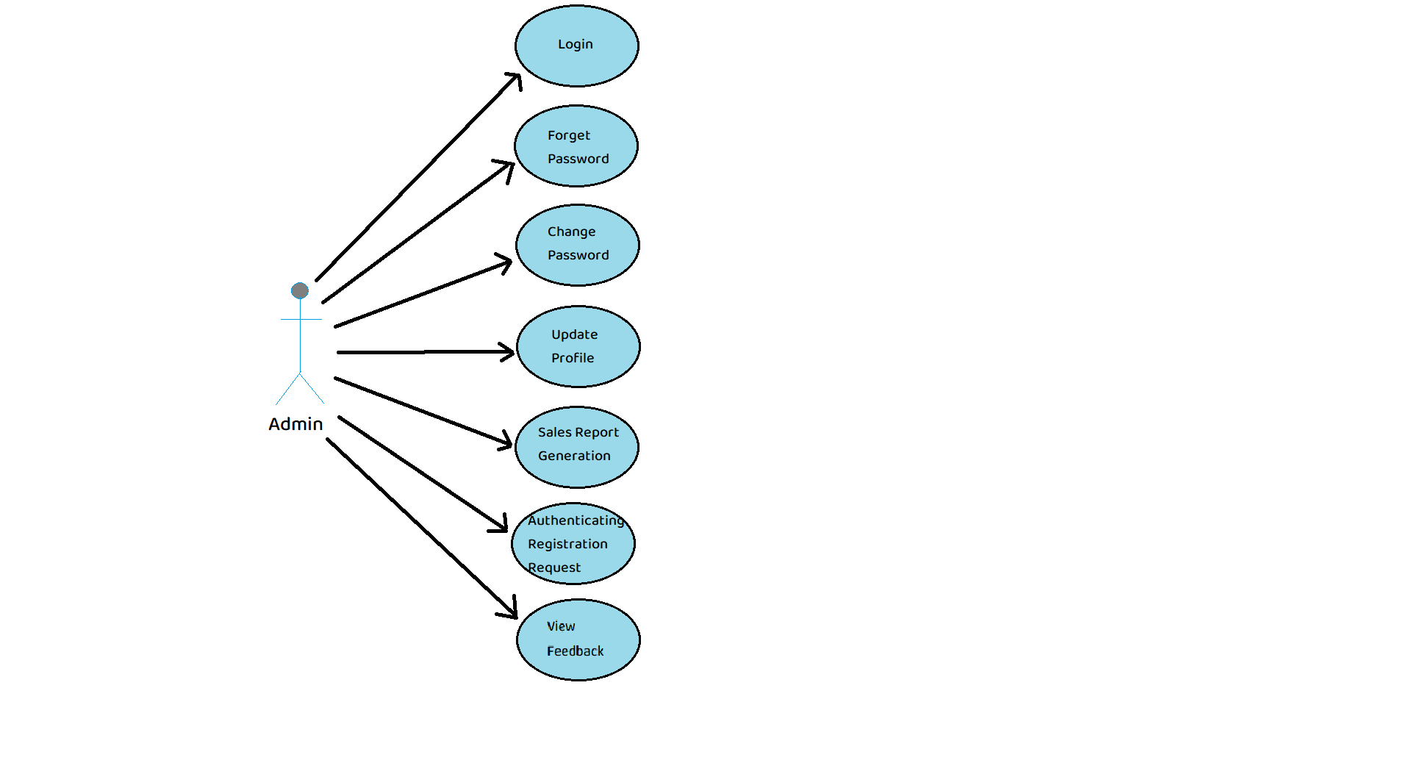

*Fig. Use case diagram for admin*

1. In Admin use case diagram Admin is the Actor.
2. Admin can handle following use cases:
3. Login
4. Update Profile
5. Sales Report Generation
6. Authenticating Registration Request
7. View Feedback

**Customer:**

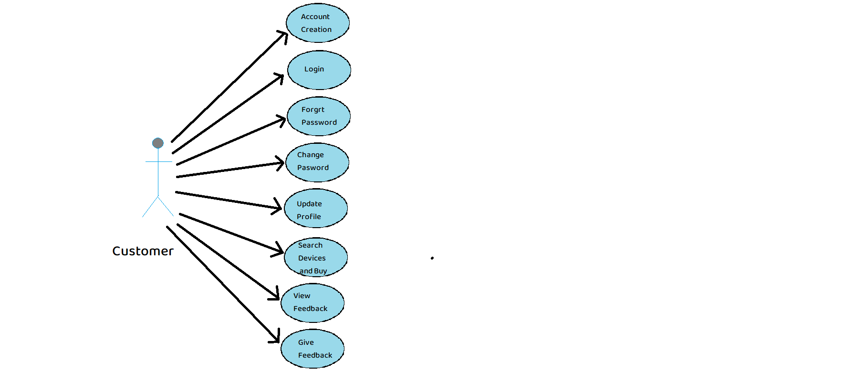

*Fig. Use case diagram for Customer*

1. In Customer use case diagram Customer is the Actor.
2. Customer can handle following use cases:
3. Register
4. Login
5. Update Profile
6. Search Devices and Buy
7. View Feedback
8. Give Feedback

**Subscribed Customer:**

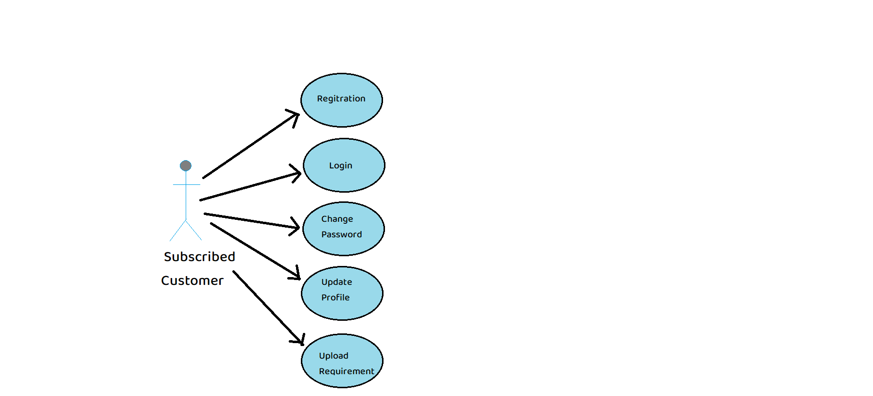

*Fig. Use case diagram for Subscribed Customer*

1. In Subscribed Customer use case diagram Wholesaler is the Actor.
2. Subscribed Customer can handle following use cases:
3. Registration
4. Login
5. Change Password
6. Update Profile
7. Upload Requirement

**Distributor:**

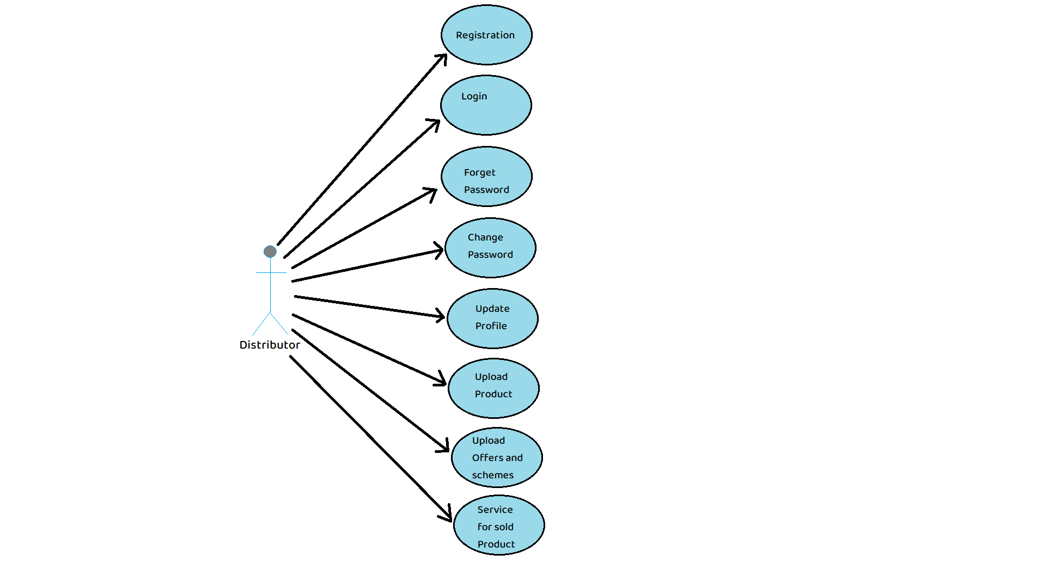

1. In Distributor use case diagram Distributor is the Actor**.**
2. Distributor can handle following use cases:
   1. Register
   2. Login
   3. Change Password
   4. Update Profile
   5. Upload Product
   6. Upload Offers and Schemes
   7. Service for sold Product

**Expert:**

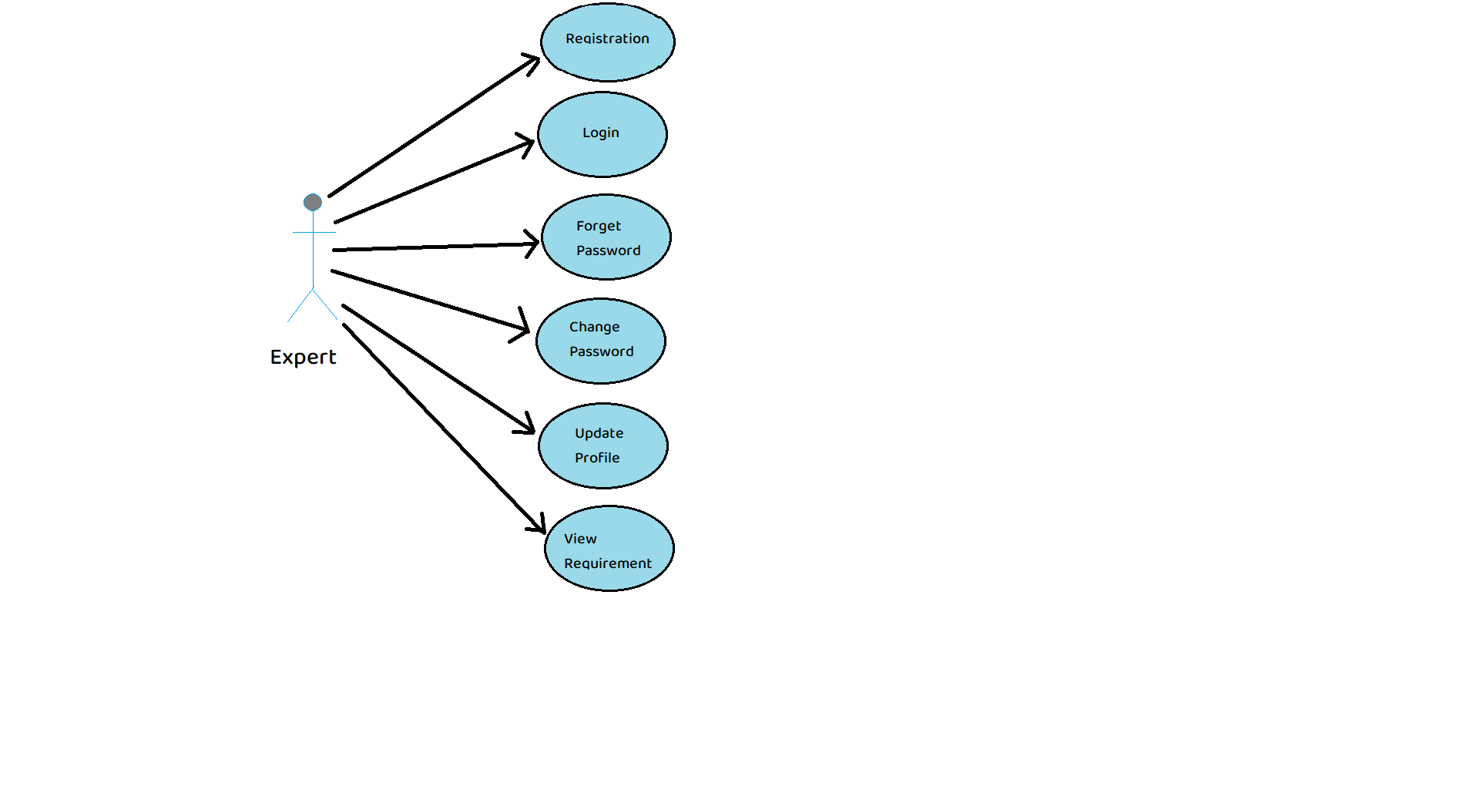

1. In Expert use case diagram Expert is the Actor**.**
2. Expert can handle following use cases:
3. Register
4. Login
5. Change Password
6. Update Profile
7. View Requirement